Minghao LI A53323531

Problem1

Code is in the Matlab file

(a)(b)

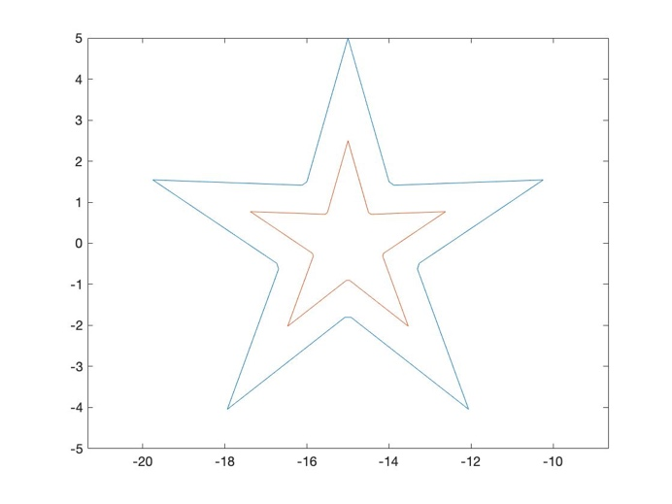

(c)

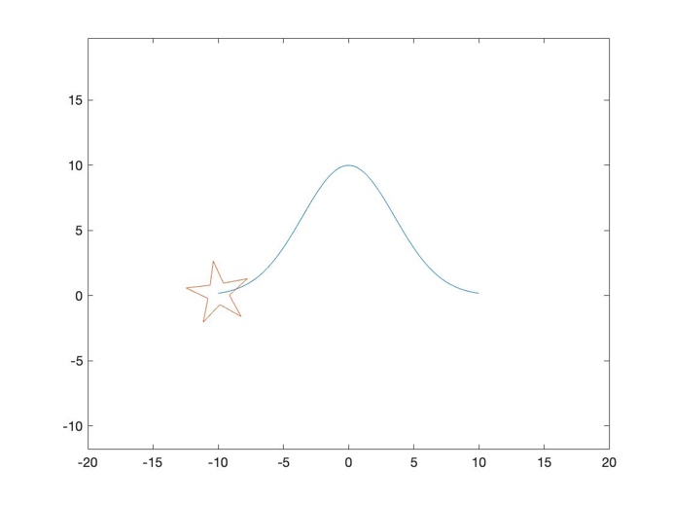

（d）

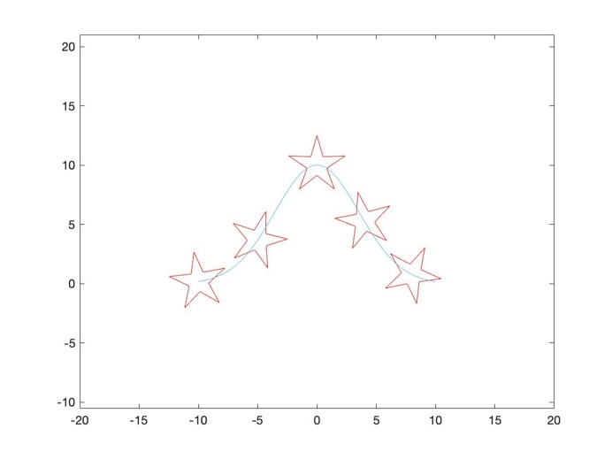





Problem 3





c

﻿<https://a360.co/37ivda5>

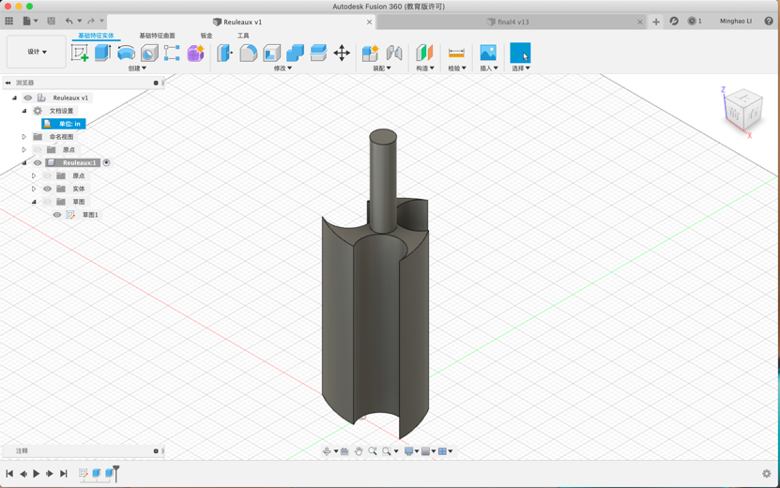

Problem 4

1. Model: ﻿<https://a360.co/3cQwQwN>

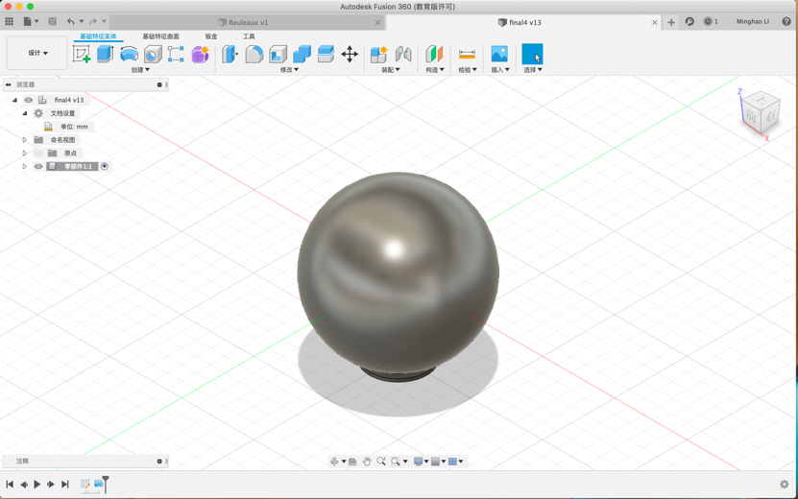

(2)

When the inner diameter is 4.6 mm, the minimal SF is 5.66. (SF > 5)

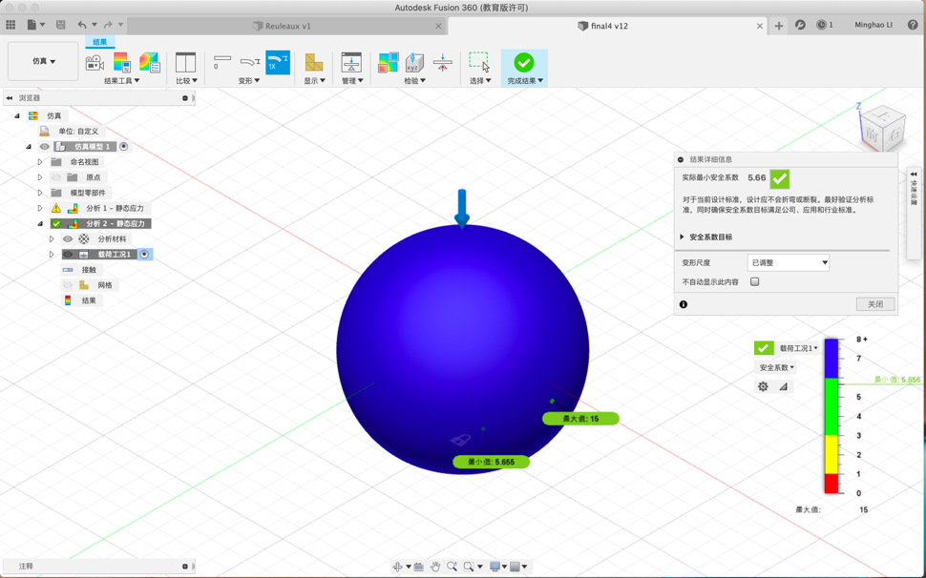

When the inner diameter is 4.7mm, the minimal SF is 3.8. (SF<5)

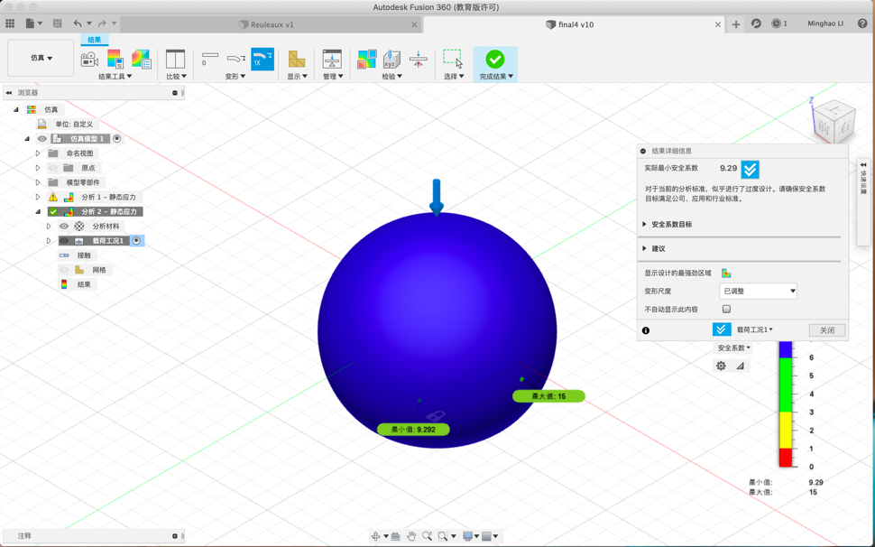

When the inner diameter is 4.5 mm, the minimal SF is 3.8. (SF<5)

